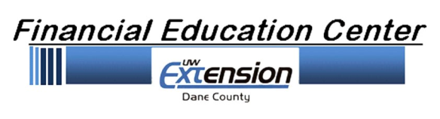

Join Our Board Of Directors!
We are looking for enthusiastic community leaders to offer expertise and experience from a wide variety of fields and be ambassadors for the Dane County UW-Financial Education Center and the work it does in the community.
What The Financial Education Center Does:
The mission of the Financial Education Center is to teach money management skills to Dane County families. The FEC , a program of Dane County UW-Extension, addresses the financial capability issues of low and moderate-income families in Dane County. The organization mobilizes volunteers and staff to provide unbiased, accessible financial education through workshops, one-on-one coaching, and various services.

Role Of Our Board:
Incorporated in 2007, the Friends of the Financial Education Center Board is a 501©3 non-profit volunteer organization which supports the Dane County UW-Extension Financial Education Center. Our board members work to advance the mission of the Financial Education Center by raising awareness of and financial support for the organization
The Financial Education Center Does:
- Attend regularly scheduled Board meetings (every other month) and committee meetings and trainings as needed
- Participate in at least one FEC volunteer opportunity or work group per year
- Attend and support special events
- Actively participate in fundraising projects and activities
- Actively recruit other members for the Board of Directors
- Contribute financially to the Financial Education Center in line with personal ability
- Enhance the organization’s public image and increase awareness of the FEC

Fundraising
Relationship Building
Events
Meetings
Direct

Infrastructure
Gift Processing
Accounting

Board Development
Recruitment
Training
Board Performance

As A Board Member, You Will Be Expected To:
Public Affairs
Advertising
Marketing
Communications

The “Friends” Board Has 4 Committees Which Serve The Following Functions:

